Analysis of Poem "The Sun Rising" by John Donne
Study Material by
Imrul Kayes Alam Sarkar
Asst. Professor & HOD

Dept. of English, S.F.S Mahavidyalaya

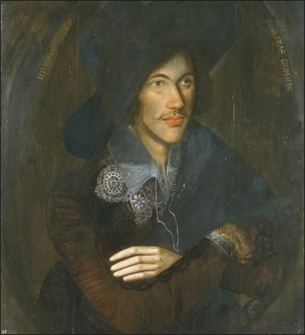
John Donne | Source

John Donne And A Summary of The Sun Rising
The Sun Rising is a love poem set in the speaker's bedroom, where he and his lover lay in bed presumably after a night of passion. The sun is seen as an unwanted dawn intruder, invading the couple's space, and is initially insulted before being challenged.
Donne wrote many an amorous poem in his younger days, using the extended metaphor or conceit to explore in depth the relationship between himself, the cosmos and love. Poems such as The Flea and To His Mistress Going to Bed are particularly popular.
Because of his interest in love, religion and morals and inventive use of form and intellectual prowess, he is often known as the father of the metaphysical poets.
Later on in life he devoted himself to religion, eventually becoming dean at St Paul's cathedral in London. His Holy Sonnets and other religious verse are a counterbalance to his more erotic writings.
John Donne's poems were first collected and published in 1633, two years after he died. No copies of his handwritten poems survive but manuscripts were circulated during his life, passing amongst friends and other admirers.
- The Sun Rising is one such poem. It begins with a rush of blood, a blunt telling off, as if the speaker's space and style has been cramped. He is annoyed. To allay the self-induced tension the speaker soon begins to compare himself with the sun, belittling the power of that mighty star, declaring love the master of all.
In the end the lovers and, more importantly, the bed in the room, become the focal point of the cosmos, around which everything revolves, even the unruly sun.

The Sun Rising
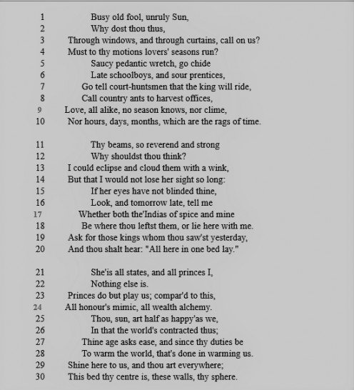

The Sun Rising - Three Stanzas
1st Stanza
The speaker has a go at the sun for invasion of privacy and declares that love isn't subject to the everyday routines, and is certainly no slave to time.
2nd Stanza
Helplessly in love with his mistress/wife, the speaker rather arrogantly belittles the sun by suggesting that his bed is the place to be.
3rd Stanza
The bed and the lovers are a microcosm of the universe, according to the speaker, who in the end invites the sun to become a part of the whole.

Analysis of The Sun Rising - Form,Syntax and Tone
Form
Three stanzas, each ten lines long, make this an unusual aubade (a dawn love poem). With irregular line length and regular rhyme scheme of abbacdcdee it is a bit of a hybrid.
The first four lines build up the argument, sonnet-like, the next four consolidate and the final couplet concludes. The meter (metre) is also varied, lines having anywhere from four to six beats, iambs mixing with anapaest and spondee to produce a stuttering uncertain rhythm.
Syntax
Short, sharp clauses, longer sentences and plenty of punctuation bring energy and emotion to the speaker's voice, and help deliver the arguments and images in a dramatic, depthful manner. Take the final couplet in the third stanza:
Shine here to us, and thou art everywhere;
This bed thy centre is, these walls, thy sphere.
Simplicity itself, with pauses that allow the reader to take in the conclusion, yet, typically of Donne, he throws in an image to catch us off guard - the bed is rectangular, the room likewise, but sphere suggests a spherical shell, one in which a celestial body might orbit in a fixed relationship.
Tone
The speaker is initially affronted by the presence of the sun and wastes no time in berating the intrusion, questioning its appearance at a time when love is the priority, and love is not to be influenced or regulated by the course of a pedant.
You can picture the lovers being disturbed by bright sunshine streaming in at dawn - the equivalent of someone shouting. All they want to do is continue their sleep. Who wouldn't be annoyed?
The speaker's tone does shift as the poem progresses. In the second stanza all the heat has dissipated and there is a more thoughtful approach as the speaker attempts to persuade the sun that his lover has the power to blind him.
In the end the speaker suggests that the lover's bed and room is a microcosm of the solar system, so the sun is invited to revolve around them.

Further Analysis - First Stanza
Lines 1-4
This poem begins with insults. The sun is called an old fool, which is quite controversial because we're talking about the giant star that keeps everyone and everything alive on the planet, right? The sun can never be unruly, surely? Donne personifies the sun in order to have a go at it. The speaker is saying : Get out of my life! Love is not under your control!!
- thou - you
- thus - in this way
Lines 5 - 8
The insults continue. You can picture the lovers being rudely awakened by the strong rays and wanting the sun to go elsewhere. But the emphasis here is on belittling - the sun is told to go and call on people arguably less important - boys late for school, resentful apprentices and farm workers.
- chide - reprimand
- prentices - apprentices
- offices - duties
Lines 9-10
The end couplet, fully rhymed, affirms that love is beyond weather, place and time of year. It never changes, is unaffected by the divisions of the clock.
- all alike - the same at all times
- clime - a region known for particular weather
- rags - fragments

Second Stanza
Lines 11-14
What makes you think your light is so awesome? All it takes is for me to blink an eye and, hey presto, I've beaten you. But I don't want to waste time doing that, my eyes are for my lover only. The speaker is boasting now, putting the sun in its place with two perfectly constructed iambic pentameter lines - to emphasise the ease with which he could eclipse the sun.
- Thy - your
- reverend - worthy of reverence
Lines 15-18
My lover's eyes easily outshine yours, she is dazzling, and it wouldn't be such a shock if, on your return tomorrow, the whole of India and the East and West Indies are all here in her, in our bed.
This is hyperbole par excellence. Donne has the speaker declaring that the exotic countries of th'Indias with their spices and gold won't be where the sun last saw them, they'll be embodied in his lover.
- thine - yours
- th'Indias of spice and mine - East and West Indies, spice from the East, gold from the West.
- thou leftst - you left
Lines 19-20
And if you saw a monarch or two on your travels yesterday ask after them, I think you'll be told they're here, in our bed.
- thou saw'st - you saw
- thou shalt - you shall

Third Stanza
Lines 21-24
My lover is the whole world to me, and I'm total prince. End of story. Real royalty act as if they're us; all rank, status, mark of pedigree is imitation compared to her and me. We're the real deal, our love is our wealth, we don't need cash or bling, especially that false fool's gold the alchemists claim to make from junk metal.
* alchemy - alchemists claimed to be able to create gold from base metals.
Lines 25-30
You're only half happy, being one. We are two and we are the entire world so, take it easy, you're old don't forget and you've still got to keep the earth warm, it's your duty after all. To make it easier, I invite you in to our room. Shine on our bed, into the whole room; that way this will become your solar system with you revolving around us.
- thy sphere - your solar system. Donne has the Ptolemaic model of the cosmos in mind, with the bed the focal point around which the sun revolves.

